Solution

1-Create a freestyle project with the name QA_UNIT_TEST in Jenkins that is driven from job DEVELOPER_CODE_REVIEW and performs unit testing

successful build of unit testing

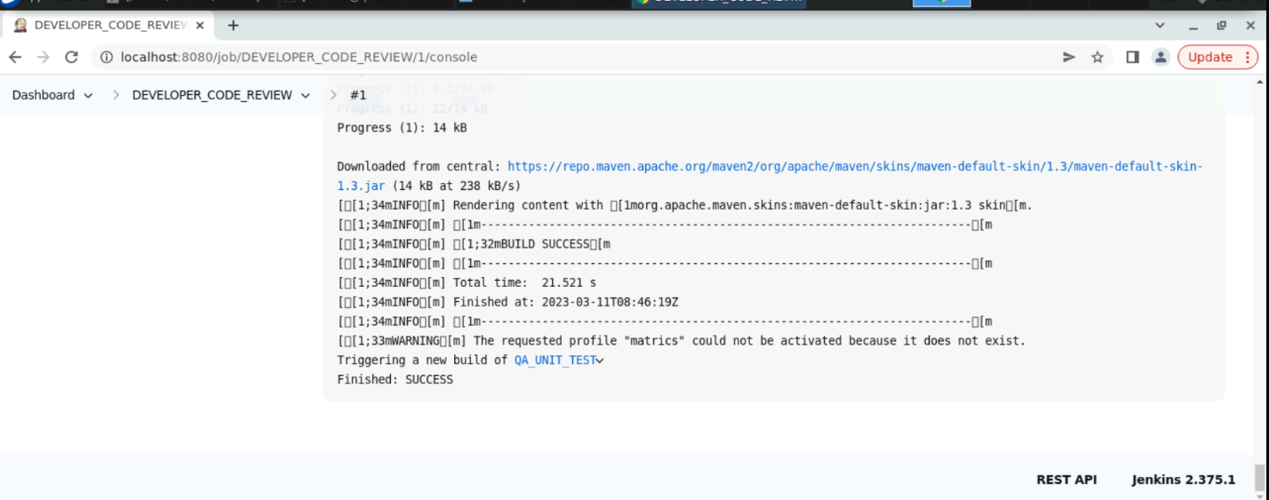

1. Create a freestyle project with the

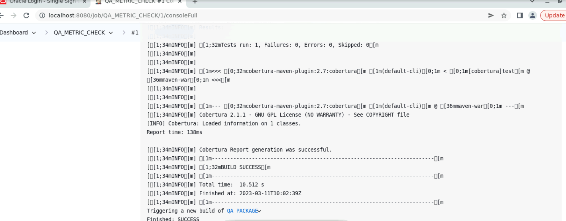name QA_ METRICS _CHECK in Jenkins to check the test cases.

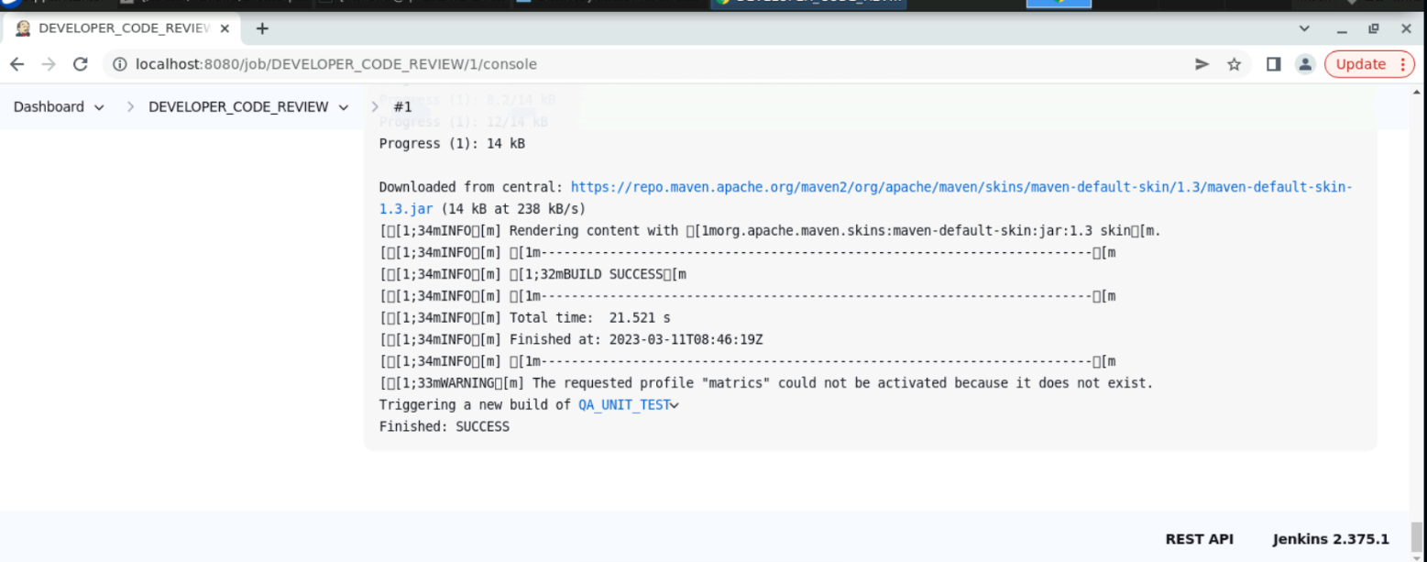

1. Create a freestyle project with the name QA_ PACKAGE in Jenkins to

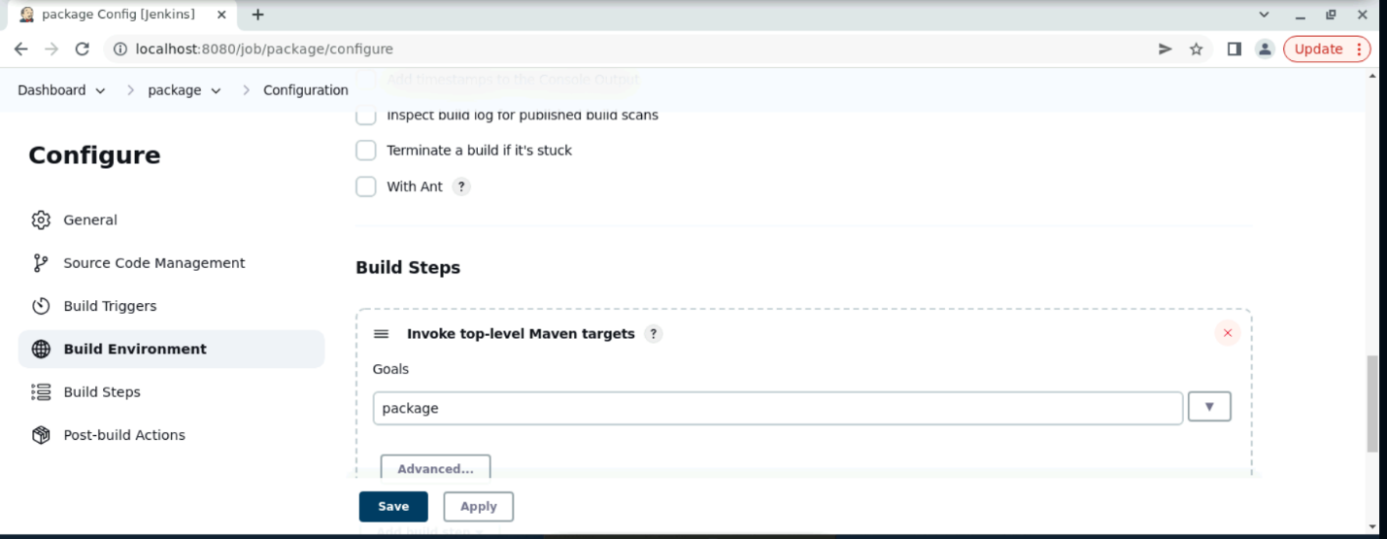

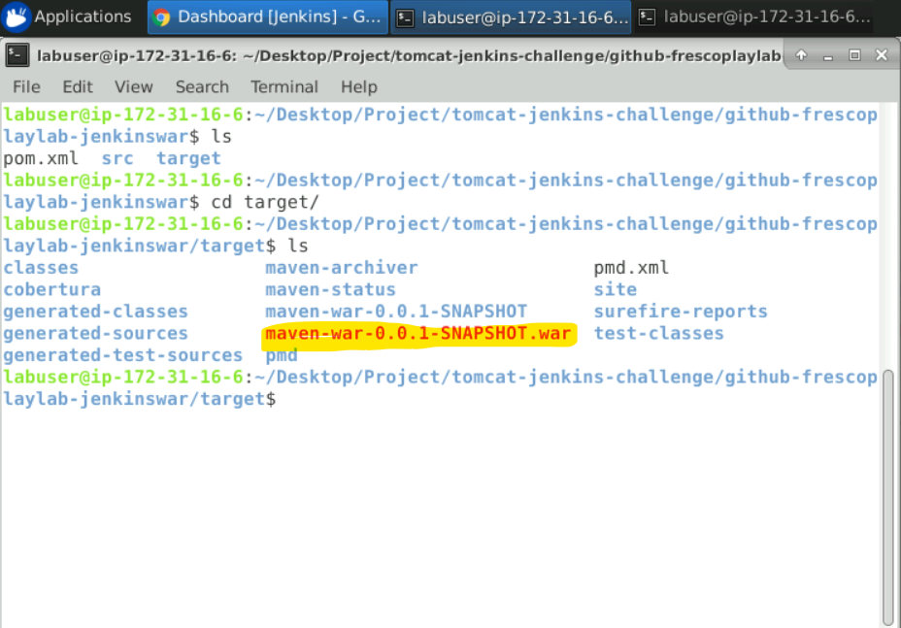

1. Create a pipeline named SAMPLE_COMPILE_VIEW with

Build Pipeline View

